C Programing Tutorial11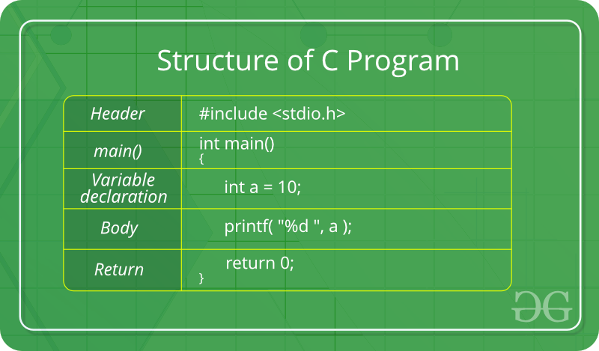

The C Language is developed by Dennis Ritchie for creating system applications that directly interact with the hardware devices such as drivers, kernels, etc.

C programming is a general-purpose, procedural, imperative computer programming language

Why to Learn C Programming?
C programming language is a MUST for students and working professionals to become a great Software Engineer specially when they are working in Software Development Domain. I will list down some of the key advantages of learning C Programming:
- Easy to learn
- Structured language
- It produces efficient programs
- It can handle low-level activities
- It can be compiled on a variety of computer platforms

Example:
d

Applications of C Programming
C was initially used for system development work, particularly the programs that make-up the operating system. Some examples of the use of C are -
- Operating Systems
- Language Compilers
- Assemblers
- Text Editors
- Network Drivers
- Databases
- Language Interpreters

Features of C Language
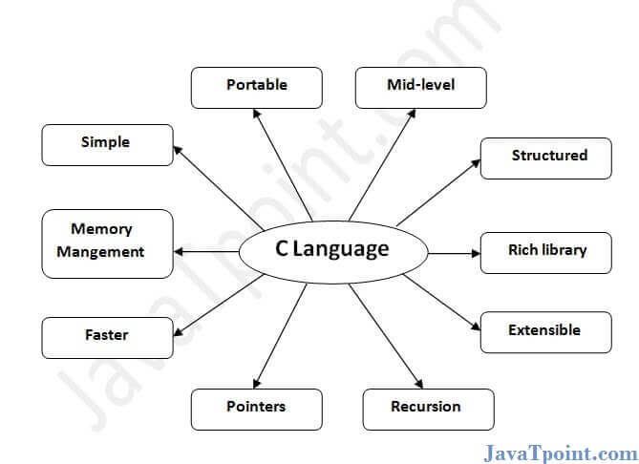
C is the widely used language. It provides many features that are given below.
- Simple
- Machine Independent or Portable
- Mid-level programming language
- structured programming language
- Rich Library
- Memory Management
- Fast Speed
- Pointers
- Recursion
- Extensible
C & C++

1) Simple
C is a simple language in the sense that it provides a structured approach (to break the problem into parts), the rich set of library functions, data types, etc.

2) Machine Independent or Portable
Unlike assembly language, c programs can be executed on different machines with some machine specific changes. Therefore, C is a machine independent language.

3) Mid-level programming language
Although, C is intended to do low-level programming. It is used to develop system applications such as kernel, driver, etc. It also supports the features of a high-level language. That is why it is known as mid-level language.

4) Structured programming language
C is a structured programming language in the sense that we can break the program into parts using functions. So, it is easy to understand and modify. Functions also provide code reusability.

5) Rich Library
C provides a lot of inbuilt functions that make the development fast.

6) Memory Management
It supports the feature of dynamic memory allocation. In C language, we can free the allocated memory at any time by calling the free() function.

7) Speed
The compilation and execution time of C language is fast since there are lesser inbuilt functions and hence the lesser overhead.

8) Pointer
C provides the feature of pointers. We can directly interact with the memory by using the pointers. We can use pointers for memory, structures, functions, array, etc.

9) Recursion
In C, we can call the function within the function. It provides code reusability for every function. Recursion enables us to use the approach of backtracking.

10) Extensible
C language is extensible because it can easily adopt new features.

printf() and scanf() in C
- #include<stdio.h>
- int main(){
- int number;
- int rollno;
- printf("enter a number:");
- scanf("%d",&number);
- printf("cube of number is:%d ",number*number*number);
- Return 0 ;
- }

Tokens in C

Tokens are the smallest elements of a program, which are meaningful to the compiler.
The following are the types of tokens: Keywords, Identifiers, Constant, Strings, Operators, etc.
Let us begin with Keywords.

Keywords
Keywords are predefined, reserved words in C and each of which is associated with specific features. These words help us to use the functionality of C language. They have special meaning to the compilers.
There are total 32 keywords in C.
auto | double | int | struct
break | else | long | switch
case | enum | register | typedef
char | extern | return | union
continue | for | signed | void
do | if | static | while
default | goto | sizeof | volatile
const | float | short | unsigned

Identifiers
Each program element in C programming is known as an identifier. They are used for naming of variables, functions, array etc. These are user-defined names which consist of alphabets, number, underscore ‘_’. Identifier’s name should not be same or same as keywords. Keywords are not used as identifiers.
Int int;
sum=a+b

Rules for naming C identifiers −
- It must begin with alphabets or underscore.
- Only alphabets, numbers, underscore can be used, no other special characters, punctuations are allowed.
- It must not contain white-space.
- It should not be a keyword.
- It should be up to 31 characters long.

Strings
Int a=10;
Int a[10];
Char ab[10]=”abcdefgh”
ab[0]=’s’;
ab[1]=’t’;
ab[1]=’u’;
Char c=’A’
Int 3ab;
Int _32b

A string is an array of characters ended with a null character(\0). This null character indicates that string has ended. Strings are always enclosed with double quotes(“ “).
Let us see how to declare String in C language −
- char string[20] = {‘s’,’t’,’u’,’d’,’y’, ‘\0’};
- char string[20] = “demo ”;
- char string [] = “demo”;
Here is an example of tokens in C language,

Example

#include <stdio.h>
int main() {
// using keyword char
char a1 = 'H';
long int b = 8;
float d = 5.6;
// declaration of string
char string[200] = "demodotcom";
if(b<10)
printf("Character Value : %c \n",a1);
else
printf("Float value : %f\n",d);
printf("String Value : %s\n", string);
return 0;
}

Output
Character Value : H
String Value : demodotcom

Data Types in C
A data type specifies the type of data that a variable can store such as integer, floating, character, etc.
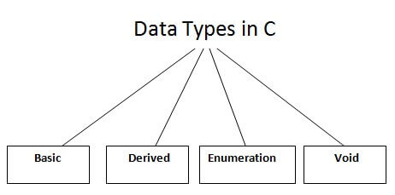
There are the following data types in C language.
Types | Data Types
Basic Data Type | int, char, float, double
Derived Data Type | array, pointer, structure, union
Enumeration Data Type | enum
Void Data Type | void

Basic Data Types
The basic data types are integer-based and floating-point based. C language supports both signed and unsigned literals.
The memory size of the basic data types may change according to 32 or 64-bit operating system.
Let's see the basic data types. Its size is given according to 32-bit architecture.

Data Types | Memory Size | Range
char | 1 byte | −128 to 127
signed char | 1 byte | −128 to 127
unsigned char | 1 byte | 0 to 255
short | 2 byte | −32,768 to 32,767
signed short | 2 byte | −32,768 to 32,767
unsigned short | 2 byte | 0 to 65,535
int | 2 byte | −32,768 to 32,767
signed int | 2 byte | −32,768 to 32,767
unsigned int | 2 byte | 0 to 65,535
short int | 2 byte | −32,768 to 32,767
signed short int | 2 byte | −32,768 to 32,767
unsigned short int | 2 byte | 0 to 65,535
long int | 4 byte | -2,147,483,648 to 2,147,483,647
signed long int | 4 byte | -2,147,483,648 to 2,147,483,647
unsigned long int | 4 byte | 0 to 4,294,967,295
float | 4 byte
double | 8 byte
long double | 10 byte

Variables in C
A variable is a name of the memory location. It is used to store data. Its value can be changed, and it can be reused many times.
It is a way to represent memory location through symbol so that it can be easily identified.
Let's see the syntax to declare a variable:
- type variable_list;
The example of declaring the variable is given below:
- int a;
- float b;
- char c;
Here, a, b, c are variables. The int, float, char are the data types.
We can also provide values while declaring the variables as given below:
- int a=10,b=20;//declaring 2 variable of integer type
- float f=20.8;
- char c='A';

Rules for defining variables
- A variable can have alphabets, digits, and underscore.
- A variable name can start with the alphabet, and underscore only. It can't start with a digit.
- No whitespace is allowed within the variable name.
- A variable name must not be any reserved word or keyword, e.g. int, float, etc.
Valid variable names:
- int a;
- int _ab;
- int a30;
Invalid variable names:
- int 2;
- int a b;
- int long;

Types of Variables in C
There are many types of variables in c:
- local variable
- global variable
- static variable
- automatic variable
- external variable

Local Variable
A variable that is declared inside the function or block is called a local variable.
It must be declared at the start of the block.
- void function1(int y){
- int x=10;//local variable
- }

You must have to initialize the local variable before it is used.

Global Variable
A variable that is declared outside the function or block is called a global variable. Any function can change the value of the global variable. It is available to all the functions.
It must be declared at the start of the block.
- int value=20;//global variable
- void function1(){
- value=20
- int x=10;//local variable
- }

Static Variable
A variable that is declared with the static keyword is called static variable.
It retains its value between multiple function calls.
- void function1(){
- int x=10;//local variable
- static int y=10;//static variable
- x=x+1;
- y=y+1;
- printf("%d,%d",x,y);
- }
If you call this function many times, the local variable will print the same value for each function call, e.g, 11,11,11 and so on. But the static variable will print the incremented value in each function call, e.g. 11, 12, 13 and so on.

Automatic Variable
All variables in C that are declared inside the block, are automatic variables by default. We can explicitly declare an automatic variable using auto keyword.
- void main(){
- int x=10;//local variable (also automatic)
- auto int y=20;//automatic variable
- }

External Variable
We can share a variable in multiple C source files by using an external variable. To declare an external variable, you need to use extern keyword.
myfile.h
- extern int x=10;//external variable (also global)
program1.c
- #include "myfile.h"
- #include <stdio.h>
- void printValue(){
- printf("Global variable: %d", global_variable);
- }
=======================================================
C Operator
An operator is a symbol that tells the compiler to perform specific mathematical or logical functions. C language is rich in built-in operators and provides the following types of operators −
- Arithmetic Operators
- Relational Operators
- Logical Operators
- Bitwise Operators
- Assignment Operators
- Misc Operators
We will, in this chapter, look into the way each operator works.

Arithmetic Operators
The following table shows all the arithmetic operators supported by the C language. Assume variable A holds 10 and variable B holds 20 then −
Show Examples
Operator | Description | Example
+ | Adds two operands. | A + B = 30
− | Subtracts second operand from the first. | A − B = -10
* | Multiplies both operands. | A * B = 200
/ | Divides numerator by de-numerator. | B / A = 2
% | Modulus Operator and remainder of after an integer division. | B % A = 0
++ | Increment operator increases the integer value by one. | A++ = 11
-- | Decrement operator decreases the integer value by one. | A-- = 9

// Working of arithmetic operators

#include <stdio.h>

int main()

{

int a = 9,b = 4, c;

c = a+b;

printf("a+b = %d \n",c);

c = a-b;

printf("a-b = %d \n",c);

c = a*b;

printf("a*b = %d \n",c);

c = a/b;

printf("a/b = %d \n",c);

c = a%b;

printf("Remainder when a divided by b = %d \n",c);

return 0;

}
Output

a+b = 13

a-b = 5

a*b = 36

a/b = 2

Remainder when a divided by b = 1

Increment Decrement Operator

#include <stdio.h>

int main()

{

int a = 10, b = 100;

float c = 10.5, d = 100.5;

printf("++a = %d \n", a++);

printf("--b = %d \n", --b);

printf("++c = %f \n", ++c);

printf("--d = %f \n", --d);

return 0;

}

++a = 11

--b = 99

++c = 11.500000

--d = 99.500000

Relational Operators
The following table shows all the relational operators supported by C. Assume variable A holds 10 and variable B holds 20 then −
Show Examples
Operator | Description | Example
== | Checks if the values of two operands are equal or not. If yes, then the condition becomes true.  if(a==b)  {  True  } | (A == B) is not true.
!= | Checks if the values of two operands are equal or not. If the values are not equal, then the condition becomes true. | (A != B) is true.
> | Checks if the value of left operand is greater than the value of right operand. If yes, then the condition becomes true. | (A > 18) is not true.
< | Checks if the value of left operand is less than the value of right operand. If yes, then the condition becomes true. | (A < B) is true.
>= | Checks if the value of left operand is greater than or equal to the value of right operand. If yes, then the condition becomes true. | (A >= B) is not true.
<= | Checks if the value of left operand is less than or equal to the value of right operand. If yes, then the condition becomes true. | (A <= B) is true.

Logical Operators
Following table shows all the logical operators supported by C language. Assume variable A holds 1 and variable B holds 0, then −
Show Examples
Operator | Description | Example
&& | Called Logical AND operator. If both the operands are non-zero, then the condition becomes true.  a=10,b=20,c=30if(a>b && a>c)  {  Statement execute  } | (A && B) is false.
|| | Called Logical OR Operator. If any of the two operands is non-zero, then the condition becomes true. | (A || B) is true.
! | Called Logical NOT Operator. It is used to reverse the logical state of its operand. If a condition is true, then Logical NOT operator will make it false. | !(A && B) is true.

Bitwise Operators
Bitwise operator works on bits and perform bit-by-bit operation. The truth tables for &, |, and ^ is as follows −
p | q | p & q | p | q | p ^ q
0 | 0 | 0 | 0 | 0
0 | 1 | 0 | 1 | 1
1 | 1 | 1 | 1 | 0
1 | 0 | 0 | 1 | 1
Assume A = 60 and B = 13 in binary format, they will be as follows −
A = 0011 1100
B = 0000 1101
128 64 32 16 8 4 2 1
0 0 1 1 1 1 0 0
--------0---0---1 1 1 1 0 0
A&B = 0000 1100
A|B = 0011 1101
A^B = 0011 0001
~A = 1100 0011
64 32 16 8 4 2 1
0 0 1 1 1 1 0 0
The following table lists the bitwise operators supported by C. Assume variable 'A' holds 60 and variable 'B' holds 13, then −
Show Examples
Operator | Description | Example
& | Binary AND Operator copies a bit to the result if it exists in both operands. | (A & B) = 12, i.e., 0000 1100
| | Binary OR Operator copies a bit if it exists in either operand. | (A | B) = 61, i.e., 0011 1101
^ | Binary XOR Operator copies the bit if it is set in one operand but not both. | (A ^ B) = 49, i.e., 0011 0001
~ | Binary One's Complement Operator is unary and has the effect of 'flipping' bits.0011 1100  1100 0011 | (~A ) = ~(60), i.e,. -0111101
<< | Binary Left Shift Operator. The left operands value is moved left by the number of bits specified by the right operand.  0011 110000 | A << 2 = 240 i.e., 1111 0000
>> | Binary Right Shift Operator. The left operands value is moved right by the number of bits specified by the right operand. | A >> 2 = 15 i.e., 0000 1111

==============================================

Assignment Operators
The following table lists the assignment operators supported by the C language −
Show Examples
Operator | Description | Example
= | Simple assignment operator. Assigns values from right side operands to left side operand  x=A+B  x+=1  x=A+1 | C = A + B will assign the value of A + B to C
+= | Add AND assignment operator. It adds the right operand to the left operand and assign the result to the left operand.  c=0  c+= | C += A is equivalent to C = C + A
-= | Subtract AND assignment operator. It subtracts the right operand from the left operand and assigns the result to the left operand. | C -= A is equivalent to C = C - A
*= | Multiply AND assignment operator. It multiplies the right operand with the left operand and assigns the result to the left operand. | C *= A is equivalent to C = C * A
/= | Divide AND assignment operator. It divides the left operand with the right operand and assigns the result to the left operand. | C /= A is equivalent to C = C / A
%= | Modulus AND assignment operator. It takes modulus using two operands and assigns the result to the left operand. | C %= A is equivalent to C = C % A
<<= | Left shift AND assignment operator. | C <<= 2 is same as C = C << 2
>>= | Right shift AND assignment operator. | C >>= 2 is same as C = C >> 2
&= | Bitwise AND assignment operator. | C &= 2 is same as C = C & 2
^= | Bitwise exclusive OR and assignment operator. | C ^= 2 is same as C = C ^ 2
|= | Bitwise inclusive OR and assignment operator. | C |= 2 is same as C = C | 2

Misc Operators ↦ sizeof & ternary
Besides the operators discussed above, there are a few other important operators including sizeof and ? : supported by the C Language.
Show Examples
Operator | Description | Example
sizeof(a) | Returns the size of a variable. | sizeof(a), where a is integer, will return 4.
& | Returns the address of a variable. | &a; returns the actual address of the variable.
* | Pointer to a variable.  a=&b | *a;
? : | Conditional Expression. | If Condition is true ? then value X : otherwise value Y

Constants in C
A constant is a value or variable that can't be changed in the program, for example: 10, 20, 'a', 3.4, "c programming" etc.
There are different types of constants in C programming.

List of Constants in C
Constant | Example
Decimal Constant | 10, 20, 450 etc.
Real or Floating-point Constant | 10.3, 20.2, 450.6 etc.
Octal Constant | 021, 033, 046 etc.
Hexadecimal Constant | 0x2a, 0x7b, 0xaa etc.
Character Constant | 'a', 'b', 'x' etc.
String Constant | "c", "c program", "c in Agile" etc.

2 ways to define constant in C
There are two ways to define constant in C programming.
- const keyword
- #define preprocessor

1) C const keyword
The const keyword is used to define constant in C programming.
- const float PI=3.14;
Now, the value of PI variable can't be changed.
- #include<stdio.h>
- #define PI 3.14
- int main(){
- const float PI=3.14;
- printf("The value of PI is: %f",PI);
- return 0;
- }
Output:
The value of PI is: 3.140000

If you try to change the the value of PI, it will render compile time error.
- #include<stdio.h>
- int main(){
- const float
- PI=3.14;
- PI=4.5;
- printf("The value of PI is: %f",PI);
- return 0;
- }
Output:
Compile Time Error: Cannot modify a const object

2) C #define preprocessor
The #define preprocessor is also used to define constant. We will learn about #define preprocessor directive later.

What are literals?
Literals are the constant values assigned to the constant variables. We can say that the literals represent the fixed values that cannot be modified. It also contains memory but does not have references as variables. For example, const int =10; is a constant integer expression in which 10 is an integer literal.
Contest int a=10

Types of literals
There are four types of literals that exist in C programming:
- Integer literal
- Float literal
- Character literal
Char a=’A’
- String literal
Char a[10]=”Java”

Integer literal
It is a numeric literal that represents only integer type values. It represents the value neither in fractional nor exponential part.

It can be specified in the following three ways:

Decimal number (base 10)
It is defined by representing the digits between 0 to 9. For example, 45, 67, etc.

Octal number (base 8)
It is defined as a number in which 0 is followed by digits such as 0,1,2,3,4,5,6,7. For example, 012, 034, 055, etc.

Hexadecimal number (base 16)
It is defined as a number in which 0x or 0X is followed by the hexadecimal digits (i.e., digits from 0 to 9, alphabetical characters from (a-z) or (A-Z)).
An integer literal is suffixed by following two sign qualifiers:
L or l: It is a size qualifier that specifies the size of the integer type as long.
U or u: It is a sign qualifier that represents the type of the integer as unsigned. An unsigned qualifier contains only positive values.

Note: The order of the qualifier is not considered, i.e., both lu and ul are the same.
Let's look at a simple example of integer literal.
- #include <stdio.h>
- int main()
- {
- const int a=23; // constant integer literal
- printf("Integer literal : %d", a);
- return 0;
- }
Output
Integer literal : 23

Float literal
It is a literal that contains only floating-point values or real numbers. These real numbers contain the number of parts such as integer part, real part, exponential part, and fractional part. The floating-point literal must be specified either in decimal or in exponential form. Let's understand these forms in brief.

Decimal form
The decimal form must contain either decimal point, exponential part, or both. If it does not contain either of these, then the compiler will throw an error. The decimal notation can be prefixed either by '+' or '-' symbol that specifies the positive and negative numbers.
Examples of float literal in decimal form are:
- 1.2, +9.0, -4.5
Let's see a simple example of float literal in decimal form.
- #include <stdio.h>
- int main()
- {
- const float a=4.5; // constant float literal
- const float b=5.6; // constant float literal
- float sum;
- sum=a+b;
- printf("%f", sum);
- return 0;
- }
Output
10.100000

Character literal
A character literal contains a single character enclosed within single quotes. If multiple characters are assigned to the variable, then we need to create a character array. If we try to store more than one character in a variable, then the warning of a multi-character character constant will be generated. Let's observe this scenario through an example.
- #include <stdio.h>
- int main()
- {
- const char c='a';
- printf("%c",c);
- return 0;
- }
Enter no 10 /n
Enter Name abc
In the above code, we have used two characters, i.e., 'ak', within single quotes. So, this statement will generate a warning as shown below.
Warning generated:
- main.c:6:18: warning: multi-character character constant
- [-Wmultichar]
- const char c='ak';
- main.c:6:18: warning: implicit conversion from 'int' to 'char'
- changes value from 24939 to 107 [-Wconstant-conversion]
- const char c='ak';
- ~ ^~~~
- 2 warnings generated.
- ? ./main
Representation of character literal
A character literal can be represented in the following ways:
- It can be represented by specifying a single character within single quotes. For example, 'a', 'b', etc.
- We can specify the escape sequence character within single quotes to represent a character literal. For example, '\n', '\a', '\b'.
- We can also use the ASCII in integer to represent a character literal. For example, the ascii value of 65 is 'A'.
- The octal and hexadecimal notation can be used as an escape sequence to represent a character literal. For example, '\023', '\0x12'.

String literal
A string literal represents multiple characters enclosed within double-quotes. It contains an additional character, i.e., '\0' (null character), which gets automatically inserted. This null character specifies the termination of the string. We can use the '+' symbol to concatenate two strings.
For example,
String1= "Java";
String2= "family";
To concatenate the above two strings, we use '+' operator, as shown in the below statement:
"Java " + "family"= java family

Storage Classes in C
Storage classes in C are used to determine the lifetime, visibility, memory location, and initial value of a variable. There are four types of storage classes in C
- Automatic
- External
- Static
- Register
Storage Classes | Storage Place | Default Value | Scope | Lifetime
auto | RAM | Garbage Value | Local | Within function
extern | RAM | Zero | Global | Till the end of the main program Maybe declared anywhere in the program
static | RAM | Zero | Local | Till the end of the main program, Retains value between multiple functions call
register | Register | Garbage Value | Local | Within the function

Automatic
- Automatic variables are allocated memory automatically at runtime.
- The visibility of the automatic variables is limited to the block in which they are defined.
- The scope of the automatic variables is limited to the block in which they are defined.The automatic variables are initialized to garbage by default.
- The memory assigned to automatic variables gets freed upon exiting from the block.
- The keyword used for defining automatic variables is auto.
- Every local variable is automatic in C by default.

Example 1
- #include <stdio.h>
- int main()
- {
- int a; //auto
- char b;
- float c;
- printf("%d %c %f",a,b,c); // printing initial default value of automatic variables a, b, and c.
- return 0;
- }
Output:
garbage garbage garbage

Static
- The variables defined as static specifier can hold their value between the multiple function calls.
- Static local variables are visible only to the function or the block in which they are defined.
- A same static variable can be declared many times but can be assigned at only one time.
- Default initial value of the static integral variable is 0 otherwise null.
- The visibility of the static global variable is limited to the file in which it has declared.
- The keyword used to define static variable is static.

Example 1
- #include<stdio.h>
- static char c;
- static int i;
- static float f;
- static char s[100];
- void main ()
- {
- printf("%d %d %f %s",c,i,f); // the initial default value of c, i, and f will be printed.
- }
Output:
0 0 0.000000 (null)

Example 2
- #include<stdio.h>
- void sum()
- {
- static int a = 10;
- static int b = 24;
- printf("%d %d \n",a,b);
- a++;
- b++;
- }
- void main()
- {
- int i;
- for(i = 0; i< 3; i++)
- {
- sum(); // The static variables holds their value between multiple function calls.
- }
- }
Output:
10 24
11 25
12 26

Register
- The variables defined as the register is allocated the memory into the CPU registers depending upon the size of the memory remaining in the CPU.
- We can not dereference the register variables, i.e., we can not use &operator for the register variable.
- The access time of the register variables is faster than the automatic variables.
- The initial default value of the register local variables is 0.
- The register keyword is used for the variable which should be stored in the CPU register. However, it is compiler?s choice whether or not; the variables can be stored in the register.
- We can store pointers into the register, i.e., a register can store the address of a variable.
- Static variables can not be stored into the register since we can not use more than one storage specifier for the same variable.

Example 1
- #include <stdio.h>
- int main()
- {
- register int a; // variable a is allocated memory in the CPU register. The initial default value of a is 0.
- printf("%d",a);
- }
Output:
0

Example 2
- #include <stdio.h>
- int main()
- {
- register int a = 0;
- printf("%u",&a); // This will give a compile time error since we can not access the address of a register variable.
- }
Output:
main.c:5:5: error: address of register variable ?a? requested
printf("%u",&a);
^~~~~~

External
- The external storage class is used to tell the compiler that the variable defined as extern is declared with an external linkage elsewhere in the program.
- The variables declared as extern are not allocated any memory. It is only declaration and intended to specify that the variable is declared elsewhere in the program.
- The default initial value of external integral type is 0 otherwise null.
- We can only initialize the extern variable globally, i.e., we can not initialize the external variable within any block or method.
- An external variable can be declared many times but can be initialized at only once.
- If a variable is declared as external then the compiler searches for that variable to be initialized somewhere in the program which may be extern or static. If it is not, then the compiler will show an error.

Example 1
- #include <stdio.h>
- int main()
- {
- extern int a;
- printf("%d",a);
- }
Output
main.c:(.text+0x6): undefined reference to `a'
collect2: error: ld returned 1 exit status

Example 2
- #include <stdio.h>
- int a;
- int main()
- {
- extern int a; // variable a is defined globally, the memory will not be allocated to a
- printf("%d",a);
- }
Output
0

Example 3
- #include <stdio.h>
- int a;
- int main()
- {
- extern int a = 0; // this will show a compiler error since we can not use extern and initializer at same time
- printf("%d",a);
- }
Output
compile time error
main.c: In function ?main?:
main.c:5:16: error: ?a? has both ?extern? and initializer
extern int a = 0;

Example 4
- #include <stdio.h>
- int main()
- {
- extern int a; // Compiler will search here for a variable a defined and initialized somewhere in the pogram or not.
- printf("%d",a);
- }
- int a = 20;
Output
20

Example 5
- extern int a;
- int a = 10;
- #include <stdio.h>
- int main()
- {
- printf("%d",a);
- }
- int a = 20; // compiler will show an error at this line
Output
compile time error

C Preprocessor Directives
The C preprocessor is a micro processor that is used by compiler to transform your code before compilation. It is called micro preprocessor because it allows us to add macros.

Note: Preprocessor direcives are executed before compilation.
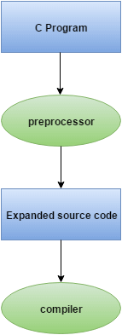
All preprocessor directives starts with hash # symbol.
Let's see a list of preprocessor directives.
- #include
- #define
- #undef
- #ifdef
- #ifndef
- #if
- #else
- #elif
- #endif
- #error
- #pragma

C Macros
A macro is a segment of code which is replaced by the value of macro. Macro is defined by #define directive.
- #define PI 3.14

C #include
The #include preprocessor directive is used to paste code of given file into current file. It is used include system-defined and user-defined header files. If included file is not found, compiler renders error.
By the use of #include directive, we provide information to the preprocessor where to look for the header files. There are two variants to use #include directive.
- #include <filename>
- #include "filename"
The #include <filename> tells the compiler to look for the directory where system header files are held. In UNIX, it is \usr\include directory.
The #include "filename" tells the compiler to look in the current directory from where program is running.

#include directive example
Let's see a simple example of #include directive. In this program, we are including stdio.h file because printf() function is defined in this file.
- #include<stdio.h>
- int main(){
- printf("Hello C");
- return 0;
- }
Output:
Hello C

C #define
The #define preprocessor directive is used to define constant or micro substitution. It can use any basic data type.
Syntax:
- #define token value
Let's see an example of #define to define a constant.
- #include <stdio.h>
- #define PI 3.14
- main() {
- printf("%f",PI);
- }
Output:
3.140000

C #undef
The #undef preprocessor directive is used to undefine the constant or macro defined by #define.
Syntax:
- #undef token
Let's see a simple example to define and undefine a constant.
- #include <stdio.h>
- #define PI 3.14
- #undef PI
- main() {
- printf("%f",PI);
- }
Output:
Compile Time Error: 'PI' undeclared

The #undef directive is used to define the preprocessor constant to a limited scope so that you can declare constant again.
Let's see an example where we are defining and undefining number variable. But before being undefined, it was used by square variable.
- #include <stdio.h>
- #define number 15
- int square=number*number;
- #undef number
- main() {
- printf("%d",square);
- }
Output:
225

C #ifdef
The #ifdef preprocessor directive checks if macro is defined by #define. If yes, it executes the code otherwise #else code is executed, if present.
Syntax:
- #ifdef MACRO
- //code
- #endif
Syntax with #else:
- #ifdef MACRO
- //successful code
- #else
- //else code
- #endif

C #ifdef example
Let's see a simple example to use #ifdef preprocessor directive.
- #include <stdio.h>

- #define NOINPUT
- void main() {
- int a=0;
- #ifdef NOINPUT
- a=2;
- #else
- printf("Enter a:");
- scanf("%d", &a);
- #endif
- printf("Value of a: %d\n", a);
- getch();
- }
Output:
Value of a: 2

Standard header files in C
In C language, header files contain the set of predefined standard library functions. The “#include” preprocessing directive is used to include the header files with “.h” extension in the program.
Here is the table that displays some of the header files in C language,
Sr.No. | Header Files & Description
1 | stdio.h  Input/Output functions
2 | conio.h  Console Input/Output functions
3 | stdlib.h  General utility functions
4 | math.h  Mathematics functions
5 | string.h  String functions
6 | ctype.h  Character handling functions
7 | time.h  Date and time functions
8 | float.h  Limits of float types
9 | limits.h  Size of basic types
10 | wctype.h  Functions to determine the type contained in wide character data.
Here is an example of header files in C language,

Example

#include <stdio.h>
#include<stdlib.h>
#include<string.h>
#include<math.h>

int main() {
char s1[20] = "53875";
char s2[10] = "Hello";
char s3[10] = "World";
int res;

res = pow(8,4);
printf("Using math.h, The value is : %d\n", res);

long int a = atol(s1);
printf("Using stdlib.h, the string to long int : %d\n", a);

strcpy(s2, s3);
printf("Using string.h, the strings s2 and s3 : %s\t%s\n", s2, s3 );

return 0;
}

Output
Here is the output −
Using math.h, The value is : 4096
Using stdlib.h, the string to long int : 53875
Using string.h, the strings s2 and s3 : World World

C - Type Casting

Converting one datatype into another is known as type casting or, type-conversion. For example, if you want to store a 'long' value into a simple integer then you can type cast 'long' to 'int'. You can convert the values from one type to another explicitly using the cast operator as follows −
(type_name) expression

Consider the following example where the cast operator causes the division of one integer variable by another to be performed as a floating-point operation −
#include <stdio.h>

main() {

int sum = 17, count = 5;
double mean;

mean = (double) sum / count;
printf("Value of mean : %f\n", mean );
}
When the above code is compiled and executed, it produces the following result −
Value of mean : 3.400000

It should be noted here that the cast operator has precedence over division, so the value of sum is first converted to type double and finally it gets divided by count yielding a double value.
Type conversions can be implicit which is performed by the compiler automatically, or it can be specified explicitly through the use of the cast operator. It is considered good programming practice to use the cast operator whenever type conversions are necessary.

Integer Promotion
Integer promotion is the process by which values of integer type "smaller" than int or unsigned int are converted either to int or unsigned int. Consider an example of adding a character with an integer −
Live Demo
#include <stdio.h>

main() {

int i = 17;
char c = 'c'; /* ascii value is 99 */
int sum;

sum = i + c;
printf("Value of sum : %d\n", sum );
}
When the above code is compiled and executed, it produces the following result −
Value of sum : 116

Here, the value of sum is 116 because the compiler is doing integer promotion and converting the value of 'c' to ASCII before performing the actual addition operation.

Usual Arithmetic Conversion
The usual arithmetic conversions are implicitly performed to cast their values to a common type. The compiler first performs integer promotion; if the operands still have different types, then they are converted to the type that appears highest in the following hierarchy −
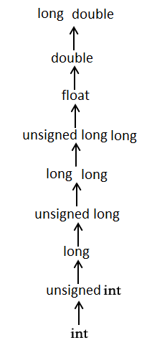
The usual arithmetic conversions are not performed for the assignment operators, nor for the logical operators && and ||. Let us take the following example to understand the concept −
Live Demo
#include <stdio.h>

main() {

int i = 17;
char c = 'c'; /* ascii value is 99 */
float sum;

sum = i + c;
printf("Value of sum : %f\n", sum );
}
When the above code is compiled and executed, it produces the following result −
Value of sum : 116.000000

Here, it is simple to understand that first c gets converted to integer, but as the final value is double, usual arithmetic conversion applies and the compiler converts i and c into 'float' and adds them yielding a 'float' result.

C if else Statement
The if-else statement in C is used to perform the operations based on some specific condition. The operations specified in if block are executed if and only if the given condition is true.
There are the following variants of if statement in C language.
- If statement
- If-else statement
- If else-if ladder
- Nested if

If Statement
The if statement is used to check some given condition and perform some operations depending upon the correctness of that condition. It is mostly used in the scenario where we need to perform the different operations for the different conditions. The syntax of the if statement is given below.
- if(expression){
- //code to be executed
- }
Flowchart of if statement in C
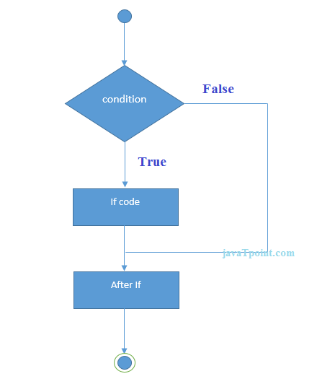
Let's see a simple example of C language if statement.
- #include<stdio.h>
- int main(){
- int number;
- printf("Enter a number:");
- scanf("%d",&number);
- if(number%2==0){
- printf("%d is even number",number);
- }
- return 0;
- }
Output
Enter a number:4
4 is even number
enter a number:5

Program to find the largest number of the three.
- #include <stdio.h>
- int main()
- {
- int a, b, c;
- printf("Enter three numbers?");
- scanf("%d %d %d",&a,&b,&c);
- if(a>b && a>c)
- {
- printf("%d is largest",a);
- }
- if(b>a && b > c)
- {
- printf("%d is largest",b);
- }
- if(c>a && c>b)
- {
- printf("%d is largest",c);
- }
- if(a == b && a == c)
- {
- printf("All are equal");
- }
- }
Output
Enter three numbers?
12 23 34
34 is largest

If-else Statement
The if-else statement is used to perform two operations for a single condition. The if-else statement is an extension to the if statement using which, we can perform two different operations, i.e., one is for the correctness of that condition, and the other is for the incorrectness of the condition. Here, we must notice that if and else block cannot be executed simiulteneously. Using if-else statement is always preferable since it always invokes an otherwise case with every if condition. The syntax of the if-else statement is given below.
- if(expression){
- //code to be executed if condition is true
- }else{
- //code to be executed if condition is false
- }
- fghfhfh
Flowchart of the if-else statement in C
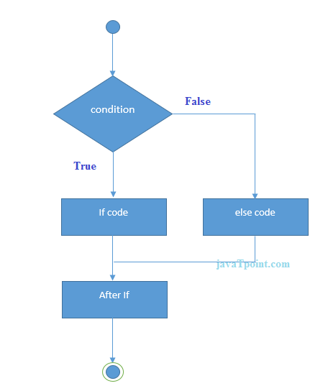
Let's see the simple example to check whether a number is even or odd using if-else statement in C language.
- #include<stdio.h>
- int main(){
- int number=0;
- printf("enter a number:");
- scanf("%d",&number);
- if(number%2==0){
- printf("%d is even number",number);
- }
- else{
- printf("%d is odd number",number);
- }
- return 0;
- }
Output
enter a number:4
4 is even number
enter a number:5
5 is odd number

Program to check whether a person is eligible to vote or not.
- #include <stdio.h>
- int main()
- {
- int age;
- printf("Enter your age?");
- scanf("%d",&age);
- if(age>=18)
- {
- printf("You are eligible to vote...");
- }
- else
- {
- printf("Sorry ... you can't vote");
- }
- }
Output
Enter your age?18
You are eligible to vote...
Enter your age?13
Sorry ... you can't vote

If else-if ladder Statement
The if-else-if ladder statement is an extension to the if-else statement. It is used in the scenario where there are multiple cases to be performed for different conditions. In if-else-if ladder statement, if a condition is true then the statements defined in the if block will be executed, otherwise if some other condition is true then the statements defined in the else-if block will be executed, at the last if none of the condition is true then the statements defined in the else block will be executed. There are multiple else-if blocks possible. It is similar to the switch case statement where the default is executed instead of else block if none of the cases is matched.
- if(condition1){
- //code to be executed if condition1 is true
- }else if(condition2){
- //code to be executed if condition2 is true
- }
- else if(condition3){
- //code to be executed if condition3 is true
- }
- ...
- else{
- //code to be executed if all the conditions are false
- }
Flowchart of else-if ladder statement in C
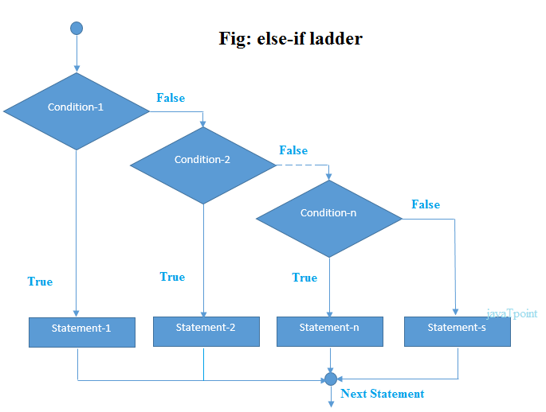
The example of an if-else-if statement in C language is given below.
- #include<stdio.h>
- int main(){
- int number=0;
- printf("enter a number:");
- scanf("%d",&number);
- if(number==10){
- printf("number is equals to 10");
- }
- else if(number==50){
- printf("number is equal to 50");
- }
- else if(number==100){
- printf("number is equal to 100");
- }
- else{
- printf("number is not equal to 10, 50 or 100");
- }
- return 0;
- }
Output
enter a number:4
number is not equal to 10, 50 or 100
enter a number:50
number is equal to 50

Program to calculate the grade of the student according to the specified marks.
- #include <stdio.h>
- int main()
- {
- int marks;
- printf("Enter your marks?");
- scanf("%d",&marks);
- if(marks > 85 && marks <= 100)
- {
- printf("Congrats ! you scored grade A ...");
- }
- else if (marks > 60 && marks <= 85)
- {
- printf("You scored grade B + ...");
- }
- else if (marks > 40 && marks <= 60)
- {
- printf("You scored grade B ...");
- }
- else if (marks > 30 && marks <= 40)
- {
- printf("You scored grade C ...");
- }
- else
- {
- printf("Sorry you are fail ...");
- }
- return
- }
Output
Enter your marks?10
Sorry you are fail ...
Enter your marks?40
You scored grade C ...
Enter your marks?90
Congrats ! you scored grade A ...

C Switch Statement
The switch statement in C is an alternate to if-else-if ladder statement which allows us to execute multiple operations for the different possibles values of a single variable called switch variable. Here, We can define various statements in the multiple cases for the different values of a single variable.
The syntax of switch statement in c language is given below:
- switch(expression){
- case value1:
- //code to be executed;
- break; //optional
- case value2:
- //code to be executed;
- break; //optional
- ......

- default:
- code to be executed if all cases are not matched;
- }

Rules for switch statement in C language
1) The switch expression must be of an integer or character type.
2) The case value must be an integer or character constant.
3) The case value can be used only inside the switch statement.
4) The break statement in switch case is not must. It is optional. If there is no break statement found in the case, all the cases will be executed present after the matched case. It is known as fall through the state of C switch statement.
Let's try to understand it by the examples. We are assuming that there are following variables.
- int x,y,z;
- char a,b;
- float f;
Valid Switch | Invalid Switch | Valid Case | Invalid Case
switch(x) | switch(f) | case 3; | case 2.5;
switch(x>y) | switch(x+2.5) | case 'a'; | case x;
switch(a+b-2) |  | case 1+2; | case x+2;
switch(func(x,y)) |  | case 'x'>'y'; | case 1,2,3;

Flowchart of switch statement in C
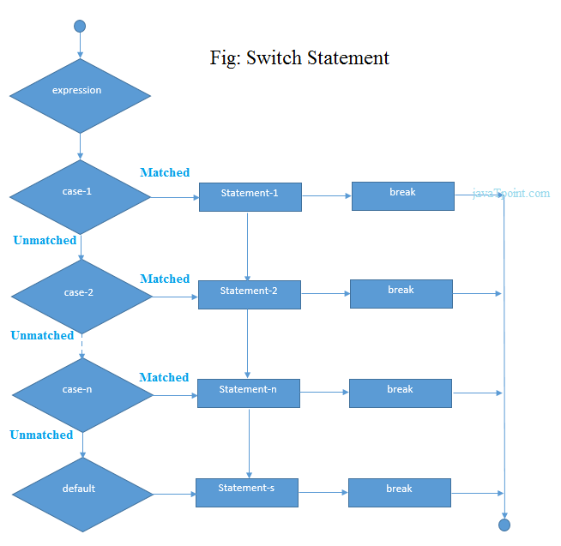

Functioning of switch case statement
First, the integer expression specified in the switch statement is evaluated. This value is then matched one by one with the constant values given in the different cases. If a match is found, then all the statements specified in that case are executed along with the all the cases present after that case including the default statement. No two cases can have similar values. If the matched case contains a break statement, then all the cases present after that will be skipped, and the control comes out of the switch. Otherwise, all the cases following the matched case will be executed.
Let's see a simple example of c language switch statement.
- #include<stdio.h>
- int main(){
- int number=100;
- printf("enter a number:");
- scanf("%d",&number);
- switch(number){
- case 10:
- printf("number is equals to 10");
- break;
- case 50:
- printf("number is equal to 50");
- break;
- case 100:
- printf("number is equal to 100");
- break;
- default:
- printf("number is not equal to 10, 50 or 100");
- }
- return 0;
- }
Output
enter a number:4
number is not equal to 10, 50 or 100

enter a number:50
number is equal to 50

Switch case example 2
- #include <stdio.h>
- int main()
- {
- int x = 10, y = 5;
- switch(x>y && x+y>0)
- {
- case 1:
- printf("hi");
- break;
- case 0:
- printf("bye");
- break;
- default:
- printf(" Hello bye ");
- }

- }
Output
hi

C Switch statement is fall-through
In C language, the switch statement is fall through; it means if you don't use a break statement in the switch case, all the cases after the matching case will be executed.
Let's try to understand the fall through state of switch statement by the example given below.
- #include<stdio.h>
- int main(){
- int number=0;

- printf("enter a number:");
- scanf("%d",&number);

- switch(number){
- case 10:
- printf("number is equal to 10\n");
- case 50:
- printf("number is equal to 50\n");
- case 100:
- printf("number is equal to 100\n");
- default:
- printf("number is not equal to 10, 50 or 100");
- }
- return 0;
- }
Output
enter a number:10
number is equal to 10
number is equal to 50
number is equal to 100
number is not equal to 10, 50 or 100

Output
enter a number:50
number is equal to 50
number is equal to 100
number is not equal to 10, 50 or 100

Nested switch case statement
We can use as many switch statement as we want inside a switch statement. Such type of statements is called nested switch case statements. Consider the following example.
- #include <stdio.h>
- int main () {

- int i = 10;
- int j = 20;

- switch(i) {

- case 10:
- printf("the value of i evaluated in outer switch: %d\n",i);
- case 20:
- switch(j) {
- case 20:
- printf("The value of j evaluated in nested switch: %d\n",j);
- }
- }

- printf("Exact value of i is : %d\n", i );
- printf("Exact value of j is : %d\n", j );

- return 0;
- }
Output
the value of i evaluated in outer switch: 10
The value of j evaluated in nested switch: 20
Exact value of i is : 10
Exact value of j is : 20

for loop in C
The for loop in C language is used to iterate the statements or a part of the program several times. It is frequently used to traverse the data structures like the array and linked list.

Syntax of for loop in C
The syntax of for loop in c language is given below:
- for(Expression 1; Expression 2; Expression 3){
- //code to be executed
- }

C for loop Examples
Let's see the simple program of for loop that prints table of 1.
- #include<stdio.h>
- int main(){
- int i;
- for(i=1;i<=10;i++){
- printf("%d \n",i);
- }

- return 0;
- }
Output
1
2
3
4
5
6
7
8
9
10

C Program: Print table for the given number using C for loop
- #include<stdio.h>
- int main(){
- int i=1,number=0;
- printf("Enter a number: ");
- scanf("%d",&number);
- for(i=1;i<=10;i++){
- printf("%d \n",(number*i));
- }
- return 0;
- }
Output
Enter a number: 2
2
4
6
8
10
12
14
16
18
20

Enter a number: 1000
1000
2000
3000
4000
5000
6000
7000
8000
9000
10000

Properties of Expression 1
- The expression represents the initialization of the loop variable.
- We can initialize more than one variable in Expression 1.
- Expression 1 is optional.
- In C, we can not declare the variables in Expression 1. However, It can be an exception in some compilers.
Example 1
How to find Nth Highest Salary in SQL
- #include <stdio.h>
- int main()
- {
- int a,b,c;
- for(a=0,b=12,c=23;a<2;a++)
- {
- printf("%d ",a+b+c);
- }
- }
Output
35 36

Example 2
- #include <stdio.h>
- int main()
- {
- int i=1;
- for(;i<5;i++)
- {
- printf("%d ",i);
- }
- }
Output
1 2 3 4

Properties of Expression 2
- Expression 2 is a conditional expression. It checks for a specific condition to be satisfied. If it is not, the loop is terminated.
- Expression 2 can have more than one condition. However, the loop will iterate until the last condition becomes false. Other conditions will be treated as statements.
- Expression 2 is optional.
- Expression 2 can perform the task of expression 1 and expression 3. That is, we can initialize the variable as well as update the loop variable in expression 2 itself.
- We can pass zero or non-zero value in expression 2. However, in C, any non-zero value is true, and zero is false by default.
Example 1
- #include <stdio.h>
- int main()
- {
- int i;
- for(i=0;i<=4;i++)
- {
- for(j=0;<=4;j++)
- {
- printf("%d ",i);
- }
- }
- }
output
0 1 2 3 4

Example 2
- #include <stdio.h>
- int main()
- {
- int i,j,k;
- for(i=0,j=0,k=0;i<4,k<8,j<10;i++)
- {
- printf("%d %d %d\n",i,j,k);
- j+=2;
- k+=3;
- }
- }
Output
0 0 0
1 2 3
2 4 6
3 6 9
4 8 12

Example 3
- #include <stdio.h>
- int main()
- {
- int i;
- for(i=0;;i++)
- {
- printf("%d",i);
- }
- }
Output
infinite loop

Properties of Expression 3
- Expression 3 is used to update the loop variable.
- We can update more than one variable at the same time.
- Expression 3 is optional.
Example 1
- #include<stdio.h>
- void main ()
- {
- int i=0,j=2;
- for(i = 0;i<5;i++,j=j+2)
- {
- printf("%d %d\n",i,j);
- }
- }
Output
0 2
1 4
2 6
3 8
4 10

Loop body
The braces {} are used to define the scope of the loop. However, if the loop contains only one statement, then we don't need to use braces. A loop without a body is possible. The braces work as a block separator, i.e., the value variable declared inside for loop is valid only for that block and not outside. Consider the following example.
- #include<stdio.h>
- void main ()
- {
- int i;
- for(i=0;i<10;i++)
- {
- int i = 20;
- printf("%d ",i);
- }
- }
Output
20 20 20 20 20 20 20 20 20 20

Infinitive for loop in C
To make a for loop infinite, we need not give any expression in the syntax. Instead of that, we need to provide two semicolons to validate the syntax of the for loop. This will work as an infinite for loop.
- #include<stdio.h>
- void main ()
- {
- for(;;)
- {
- printf("welcome to Agile");
- }
- }
If you run this program, you will see above statement infinite times.

while loop in C
While loop is also known as a pre-tested loop. In general, a while loop allows a part of the code to be executed multiple times depending upon a given boolean condition. It can be viewed as a repeating if statement. The while loop is mostly used in the case where the number of iterations is not known in advance.

Syntax of while loop in C language
The syntax of while loop in c language is given below:
- while(condition){
- //code to be executed
- }

Example of the while loop in C language
Let's see the simple program of while loop that prints table of 1.
- #include<stdio.h>
- int main(){
- int i=1;
- while(i<=10){
- printf("%d \n",i);
- i++;
- }
- return 0;
- }

Output
1
2
3
4
5
6
7
8
9
10

Program to print table for the given number using while loop in C
- #include<stdio.h>
- int main(){
- int i=1,number=0,b=9;
- printf("Enter a number: ");
- scanf("%d",&number);
- while(i<=10){
- printf("%d \n",(number*i));
- i++;
- }
- return 0;
- }

Output
Enter a number: 50
50
100
150
200
250
300
350
400
450
500

do while loop in C
The do while loop is a post tested loop. Using the do-while loop, we can repeat the execution of several parts of the statements. The do-while loop is mainly used in the case where we need to execute the loop at least once. The do-while loop is mostly used in menu-driven programs where the termination condition depends upon the end user.

do while loop syntax
The syntax of the C language do-while loop is given below:
- do{
- //code to be executed
- }while(condition);

Example 1
- #include<stdio.h>
- #include<stdlib.h>
- void main ()
- {
- char c;
- int choice,dummy;
- do{
- printf("\n1. Print Hello\n2. Print Java point\n3. Exit\n");
- scanf("%d",&choice);
- switch(choice)
- {
- case 1 :
- printf("Hello");
- break;
- case 2:
- printf("Java point");
- break;
- case 3:
- exit(0);
- break;
- default:
- printf("please enter valid choice");
- }
- printf("do you want to enter more?");
- // scanf("%d",&dummy);
- scanf("%c",&c);
- }while(c=='y');
- }

Output
1. Print Hello
2. Print C Prog
3. Exit
1
Hello
do you want to enter more?
y

1. Print Hello
2. Print C Prog
3. Exit
2
C Prog
do you want to enter more?
n

C - Variable Scope

A scope in any programming is a region of the program where a defined variable can have its existence and beyond that variable it cannot be accessed. There are three places where variables can be declared in C programming language −
- Inside a function or a block which is called local variables.
- Outside of all functions which is called global variables.
- In the definition of function parameters which are called formal parameters.
Let us understand what are local and global variables, and formal parameters.

Local Variables
Variables that are declared inside a function or block are called local variables. They can be used only by statements that are inside that function or block of code. Local variables are not known to functions outside their own. The following example shows how local variables are used. Here all the variables a, b, and c are local to main() function.
Live Demo
#include <stdio.h>

int main () {

/* local variable declaration */
int a, b;
int c;

/* actual initialization */
a = 10;
b = 20;
c = a + b;

printf ("value of a = %d, b = %d and c = %d\n", a, b, c);

return 0;
}

Global Variables
Global variables are defined outside a function, usually on top of the program. Global variables hold their values throughout the lifetime of your program and they can be accessed inside any of the functions defined for the program.
A global variable can be accessed by any function. That is, a global variable is available for use throughout your entire program after its declaration. The following program show how global variables are used in a program.
#include <stdio.h>

/* global variable declaration */
int g;

int main () {

/* local variable declaration */
int a, b;

/* actual initialization */
a = 10;
b = 20;
g = a + b;

printf ("value of a = %d, b = %d and g = %d\n", a, b, g);

return 0;
}
A program can have same name for local and global variables but the value of local variable inside a function will take preference. Here is an example −
#include <stdio.h>

/* global variable declaration */
int g = 20;

int main () {

/* local variable declaration */
int g = 10;

printf ("value of g = %d\n", g);

return 0;
}
When the above code is compiled and executed, it produces the following result −
value of g = 10

Formal Parameters
Formal parameters, are treated as local variables with-in a function and they take precedence over global variables. Following is an example −
#include <stdio.h>

/* global variable declaration */
int a = 20;

int main () {

/* local variable declaration in main function */
int a = 10;
int b = 20;
int c = 0;

printf ("value of a in main() = %d\n", a);
c = sum( a, b);
printf ("value of c in main() = %d\n", c);

return 0;
}

/* function to add two integers */
int sum(int a, int b) {

printf ("value of a in sum() = %d\n", a);
printf ("value of b in sum() = %d\n", b);

return a + b;
}
When the above code is compiled and executed, it produces the following result −
value of a in main() = 10
value of a in sum() = 10
value of b in sum() = 20
value of c in main() = 30

